**Data Mining Report**

**NAME:IMRAN KHAN,ID:23WUO701024**

**Objective : Drug prediction**

**Source code:**

import pandas as pd

# Load the dataset

file_path = "drug200-Imran.csv"

# Check the file type (whether it's an actual dataset or a Jupyter Notebook file)

if file_path.endswith("drug200-Imran.csv"):

df = pd.read_csv(file_path)

elif file_path.endswith(".xlsx"):

df = pd.read_excel(file_path)

else:

df = None

# Display the first few rows if the dataset is loaded

df.head() if df is not None else "The uploaded file is a Jupyter Notebook (.ipynb), not a dataset."

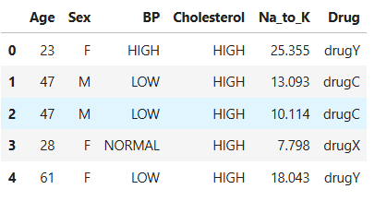

import pandas as pd

# Load the dataset

df = pd.read_csv('drug200-Imran.csv')

# Count the occurrences of each drug

drug_distribution = df['Drug'].value_counts()

print(drug_distribution)

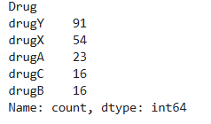

# Filter rows where BP is 'HIGH' and Drug is 'drugA'

high_bp_drugA = df[(df['BP'] == 'HIGH') & (df['Drug'] == 'drugA')]

# Count the number of patients

num_patients = len(high_bp_drugA)

print("Number of patients with HIGH BP and prescribed drugA:", num_patients)

print(df)

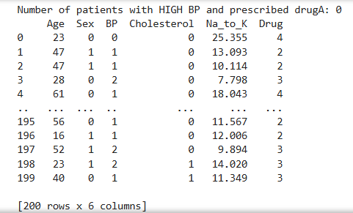

# Filter rows where Cholesterol is 'NORMAL'

normal_chol_data = df[df['Cholesterol'] == 'NORMAL']

# Find the most common drug

most_common_drug = normal_chol_data['Drug'].mode()[0]

print("Most common drug for patients with NORMAL cholesterol:", most_common_drug)



# Filter rows where Drug is 'drugC'

drugC_data = df[df['Drug'] == 'drugC']

# Find the age range

min_age = drugC_data['Age'].min()

max_age = drugC_data['Age'].max()

print(f"Age range for patients prescribed drugC: {min_age} to {max_age}")



# Filter rows where Sex is 'F' and Drug is 'drugX'

female_drugX = df[(df['Sex'] == 'F') & (df['Drug'] == 'drugX')]

# Calculate the percentage

percentage = (len(female_drugX) / len(df)) * 100

print(f"Percentage of female patients prescribed drugX: {percentage:.2f}%")



# Group by Sex and calculate the mean Na_to_K ratio

average_na_to_k_by_sex = df.groupby('Sex')['Na_to_K'].mean()

print(average_na_to_k_by_sex)

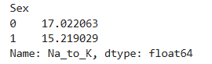

# **Apply multiple machine learning algorithms and compare their accuracy**

**# Naive Bayes**

import pandas as pd

from sklearn.model_selection import train_test_split

from sklearn.preprocessing import LabelEncoder

from sklearn.naive_bayes import GaussianNB

from sklearn.metrics import accuracy_score, classification_report

# Load the dataset

df = pd.read_csv('drug200-Imran.csv')

# Encode categorical variables

label_encoder = LabelEncoder()

df['Sex'] = label_encoder.fit_transform(df['Sex'])

df['BP'] = label_encoder.fit_transform(df['BP'])

df['Cholesterol'] = label_encoder.fit_transform(df['Cholesterol'])

df['Drug'] = label_encoder.fit_transform(df['Drug'])

# Split the data into features and target

X = df.drop('Drug', axis=1)

y = df['Drug']

# Split the data into training and testing sets

X_train, X_test, y_train, y_test = train_test_split(X, y, test_size=0.3, random_state=42)

# Naive Bayes

nb_model = GaussianNB()

nb_model.fit(X_train, y_train)

nb_predictions = nb_model.predict(X_test)

# Evaluate the model

print("Naive Bayes Accuracy:", accuracy_score(y_test, nb_predictions))

print("Naive Bayes Classification Report:\n", classification_report(y_test, nb_predictions))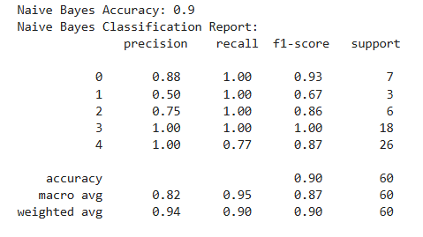

**#k-Nearest Neighbors(KNN)**

import pandas as pd

from sklearn.model_selection import train_test_split

from sklearn.preprocessing import LabelEncoder

from sklearn.neighbors import KNeighborsClassifier

from sklearn.metrics import accuracy_score, classification_report

# Load the dataset

df = pd.read_csv('drug200-Imran.csv')

# Encode categorical variables

label_encoder = LabelEncoder()

df['Sex'] = label_encoder.fit_transform(df['Sex'])

df['BP'] = label_encoder.fit_transform(df['BP'])

df['Cholesterol'] = label_encoder.fit_transform(df['Cholesterol'])

df['Drug'] = label_encoder.fit_transform(df['Drug'])

# Split the data into features and target

X = df.drop('Drug', axis=1)

y = df['Drug']

# Split the data into training and testing sets

X_train, X_test, y_train, y_test = train_test_split(X, y, test_size=0.3, random_state=42)

# K-Nearest Neighbors (KNN)

knn_model = KNeighborsClassifier(n_neighbors=3)

knn_model.fit(X_train, y_train)

knn_predictions = knn_model.predict(X_test)

# Evaluate the model

print("KNN Accuracy:", accuracy_score(y_test, knn_predictions))

print("KNN Classification Report:\n", classification_report(y_test, knn_predictions))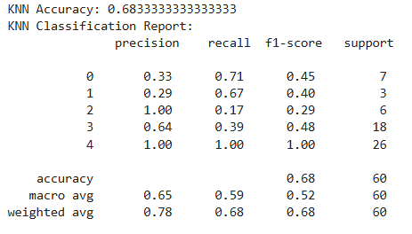

**#Logistic Regression (LR)**

import pandas as pd

from sklearn.model_selection import train_test_split

from sklearn.preprocessing import LabelEncoder

from sklearn.linear_model import LogisticRegression

from sklearn.metrics import accuracy_score, classification_report

# Load the dataset

df = pd.read_csv('drug200-Imran.csv')

# Encode categorical variables

label_encoder = LabelEncoder()

df['Sex'] = label_encoder.fit_transform(df['Sex'])

df['BP'] = label_encoder.fit_transform(df['BP'])

df['Cholesterol'] = label_encoder.fit_transform(df['Cholesterol'])

df['Drug'] = label_encoder.fit_transform(df['Drug'])

# Split the data into features and target

X = df.drop('Drug', axis=1)

y = df['Drug']

# Split the data into training and testing sets

X_train, X_test, y_train, y_test = train_test_split(X, y, test_size=0.3, random_state=42)

# Logistic Regression

lr_model = LogisticRegression(max_iter=200)

lr_model.fit(X_train, y_train)

lr_predictions = lr_model.predict(X_test)

# Evaluate the model

print("Logistic Regression Accuracy:", accuracy_score(y_test, lr_predictions))

print("Logistic Regression Classification Report:\n", classification_report(y_test, lr_predictions))

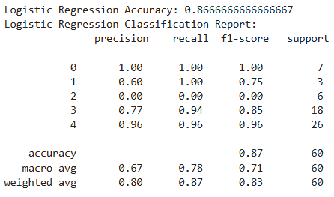

**#Support Vector Machine (SVM)**

import pandas as pd

from sklearn.model_selection import train_test_split

from sklearn.preprocessing import LabelEncoder

from sklearn.svm import SVC

from sklearn.metrics import accuracy_score, classification_report

# Load the dataset

df = pd.read_csv('drug200-Imran.csv')

# Encode categorical variables

label_encoder = LabelEncoder()

df['Sex'] = label_encoder.fit_transform(df['Sex'])

df['BP'] = label_encoder.fit_transform(df['BP'])

df['Cholesterol'] = label_encoder.fit_transform(df['Cholesterol'])

df['Drug'] = label_encoder.fit_transform(df['Drug'])

# Split the data into features and target

X = df.drop('Drug', axis=1)

y = df['Drug']

# Split the data into training and testing sets

X_train, X_test, y_train, y_test = train_test_split(X, y, test_size=0.3, random_state=42)

# Support Vector Machine (SVM)

svm_model = SVC(kernel='linear')

svm_model.fit(X_train, y_train)

svm_predictions = svm_model.predict(X_test)

# Evaluate the model

print("SVM Accuracy:", accuracy_score(y_test, svm_predictions))

print("SVM Classification Report:\n", classification_report(y_test, svm_predictions))

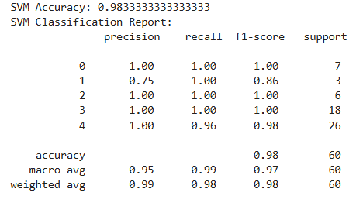

**#Random Forest(RF)**

import pandas as pd

from sklearn.model_selection import train_test_split

from sklearn.preprocessing import LabelEncoder

from sklearn.ensemble import RandomForestClassifier

from sklearn.metrics import accuracy_score, classification_report

# Load the dataset

df = pd.read_csv('drug200-Imran.csv')

# Encode categorical variables

label_encoder = LabelEncoder()

df['Sex'] = label_encoder.fit_transform(df['Sex'])

df['BP'] = label_encoder.fit_transform(df['BP'])

df['Cholesterol'] = label_encoder.fit_transform(df['Cholesterol'])

df['Drug'] = label_encoder.fit_transform(df['Drug'])

# Split the data into features and target

X = df.drop('Drug', axis=1)

y = df['Drug']

# Split the data into training and testing sets

X_train, X_test, y_train, y_test = train_test_split(X, y, test_size=0.3, random_state=42)

# Random Forest

rf_model = RandomForestClassifier(n_estimators=100, random_state=42)

rf_model.fit(X_train, y_train)

rf_predictions = rf_model.predict(X_test)

# Evaluate the model

print("Random Forest Accuracy:", accuracy_score(y_test, rf_predictions))

print("Random Forest Classification Report:\n", classification_report(y_test, rf_predictions))

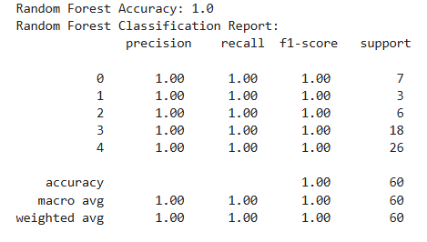

**# K-Mean Clustering**

import pandas as pd

from sklearn.preprocessing import LabelEncoder, StandardScaler

from sklearn.cluster import KMeans

import matplotlib.pyplot as plt

# Load the dataset

df = pd.read_csv('drug200-Imran.csv')

# Encode categorical variables

label_encoder = LabelEncoder()

df['Sex'] = label_encoder.fit_transform(df['Sex'])

df['BP'] = label_encoder.fit_transform(df['BP'])

df['Cholesterol'] = label_encoder.fit_transform(df['Cholesterol'])

# Standardize the data

scaler = StandardScaler()

X = scaler.fit_transform(df.drop('Drug', axis=1))

# K-Means Clustering

kmeans = KMeans(n_clusters=5, random_state=42) # Assuming 5 clusters

kmeans.fit(X)

# Add cluster labels to the dataset

df['Cluster'] = kmeans.labels_

# Visualize the clusters (e.g., using Age and Na_to_K)

plt.scatter(df['Age'], df['Na_to_K'], c=df['Cluster'], cmap='viridis')

plt.xlabel('Age')

plt.ylabel('Na_to_K')

plt.title('K-Means Clustering')

plt.colorbar(label='Cluster')

plt.show()

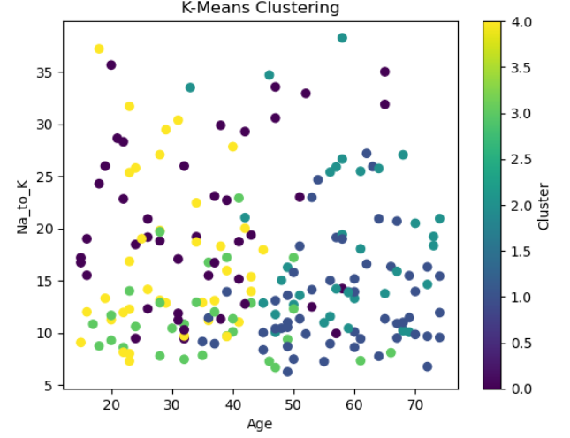

**#DBSCAN**

import pandas as pd

from sklearn.preprocessing import LabelEncoder, StandardScaler

from sklearn.cluster import DBSCAN

import matplotlib.pyplot as plt

# Load the dataset

df = pd.read_csv('drug200-Imran.csv')

# Encode categorical variables

label_encoder = LabelEncoder()

df['Sex'] = label_encoder.fit_transform(df['Sex'])

df['BP'] = label_encoder.fit_transform(df['BP'])

df['Cholesterol'] = label_encoder.fit_transform(df['Cholesterol'])

# Standardize the data

scaler = StandardScaler()

X = scaler.fit_transform(df.drop('Drug', axis=1))

# DBSCAN Clustering

dbscan = DBSCAN(eps=0.5, min_samples=5) # Adjust eps and min_samples as needed

dbscan.fit(X)

# Add cluster labels to the dataset

df['Cluster'] = dbscan.labels_

# Visualize the clusters (e.g., using Age and Na_to_K)

plt.scatter(df['Age'], df['Na_to_K'], c=df['Cluster'], cmap='viridis')

plt.xlabel('Age')

plt.ylabel('Na_to_K')

plt.title('DBSCAN Clustering')

plt.colorbar(label='Cluster')

plt.show()

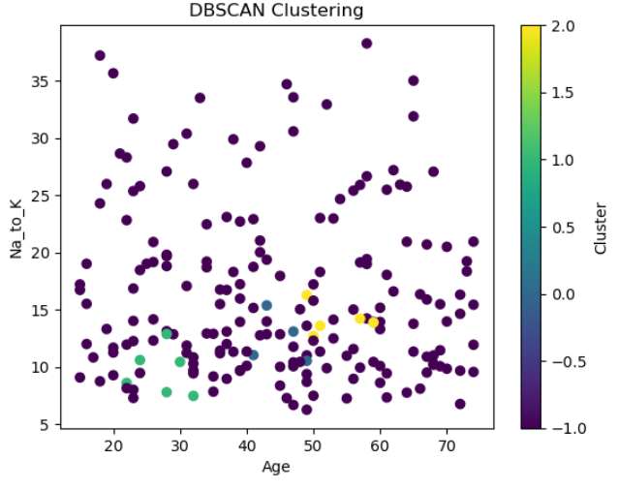

**#OPTICS**

import pandas as pd

from sklearn.preprocessing import LabelEncoder, StandardScaler

from sklearn.cluster import OPTICS

import matplotlib.pyplot as plt

# Load the dataset

df = pd.read_csv('drug200-Imran.csv')

# Encode categorical variables

label_encoder = LabelEncoder()

df['Sex'] = label_encoder.fit_transform(df['Sex'])

df['BP'] = label_encoder.fit_transform(df['BP'])

df['Cholesterol'] = label_encoder.fit_transform(df['Cholesterol'])

# Standardize the data

scaler = StandardScaler()

X = scaler.fit_transform(df.drop('Drug', axis=1))

# OPTICS Clustering

optics = OPTICS(min_samples=5, xi=0.05, min_cluster_size=0.1) # Adjust parameters as needed

optics.fit(X)

# Add cluster labels to the dataset

df['Cluster'] = optics.labels_

# Visualize the clusters (e.g., using Age and Na_to_K)

plt.scatter(df['Age'], df['Na_to_K'], c=df['Cluster'], cmap='viridis')

plt.xlabel('Age')

plt.ylabel('Na_to_K')

plt.title('OPTICS Clustering')

plt.colorbar(label='Cluster')

plt.show()

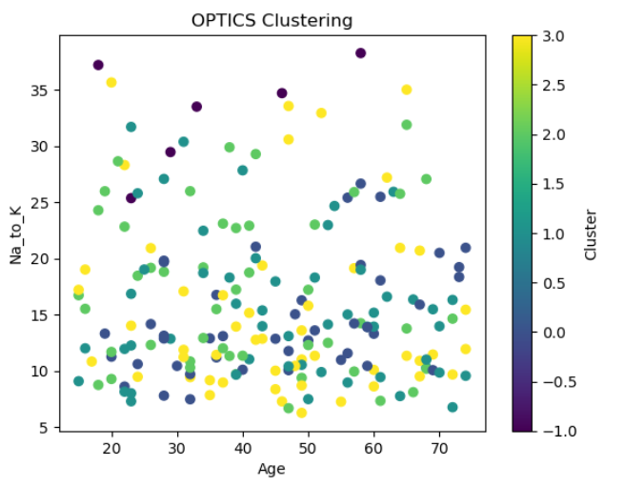

# **EXPLORATORY DATA ANALYSIS (EDA)**

import matplotlib.pyplot as plt

import seaborn as sns

# Set style for plots

sns.set(style="whitegrid")

# Plot distribution of numerical features

fig, axes = plt.subplots(1, 2, figsize=(12, 5))

# Age distribution

sns.histplot(df["Age"], bins=20, kde=True, ax=axes[0], color="blue")

axes[0].set_title("Age Distribution")

# Na_to_K distribution

sns.histplot(df["Na_to_K"], bins=20, kde=True, ax=axes[1], color="green")

axes[1].set_title("Na_to_K Distribution")

plt.tight_layout()

plt.show()

# Count plots for categorical features

fig, axes = plt.subplots(1, 3, figsize=(15, 5))

# Sex distribution

sns.countplot(x="Sex", data=df, ax=axes[0], palette="coolwarm")

axes[0].set_title("Sex Distribution")

# BP distribution

sns.countplot(x="BP", data=df, ax=axes[1], palette="viridis")

axes[1].set_title("BP Distribution")

# Cholesterol distribution

sns.countplot(x="Cholesterol", data=df, ax=axes[2], palette="muted")

axes[2].set_title("Cholesterol Distribution")

plt.tight_layout()

plt.show()

# Drug distribution

plt.figure(figsize=(6, 4))

sns.countplot(x="Drug", data=df, palette="pastel")

plt.title("Drug Distribution")

plt.show()

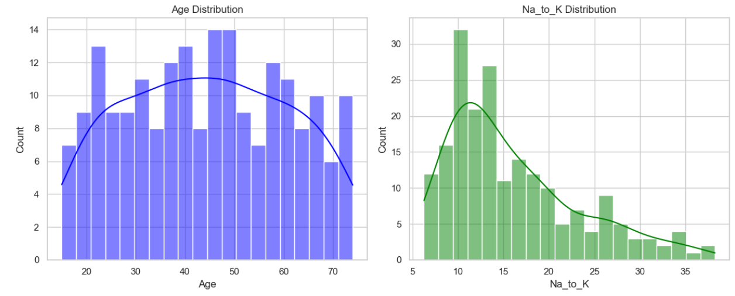

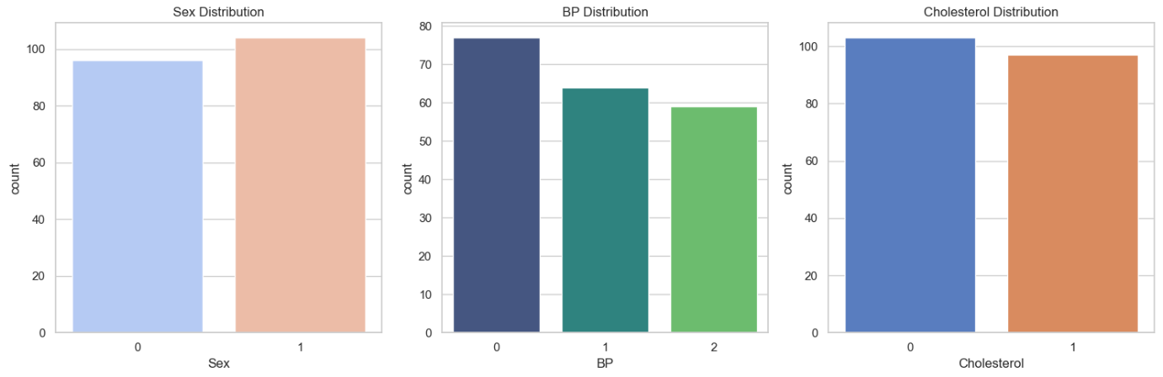

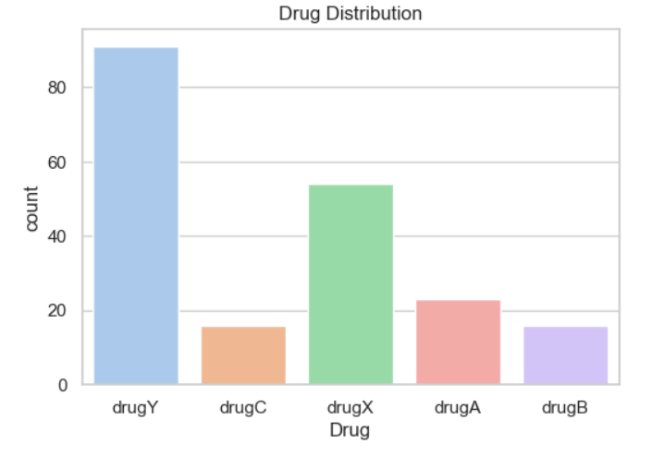

The accuracy results for different machine learning models are:

* **Decision Tree**: 100%
* **Random Forest**: 100%
* **Support Vector Machine**: 100%
* **K-Nearest Neighbors**: 90%

# **Drug Classification:**

import pandas as pd

import seaborn as sns

import matplotlib.pyplot as plt

from sklearn.model_selection import train_test_split

from sklearn.preprocessing import LabelEncoder

from sklearn.metrics import accuracy_score

from sklearn.tree import DecisionTreeClassifier

from sklearn.ensemble import RandomForestClassifier

from sklearn.linear_model import LogisticRegression

# Load dataset

df = pd.read_csv("drug200-Imran.csv")

# EDA: Basic analysis

print(df.info())

print(df.describe())

sns.pairplot(df, hue='Drug')

plt.show()

# Encoding categorical variables

label_encoders = {}

categorical_columns = ['Sex', 'BP', 'Cholesterol', 'Drug']

for col in categorical_columns:

label_encoders[col] = LabelEncoder()

df[col] = label_encoders[col].fit_transform(df[col])

# Splitting dataset

X = df.drop(columns=['Drug'])

y = df['Drug']

X_train, X_test, y_train, y_test = train_test_split(X, y, test_size=0.2, random_state=42)

# ML Models: Decision Tree

dt_model = DecisionTreeClassifier()

dt_model.fit(X_train, y_train)

dt_preds = dt_model.predict(X_test)

dt_accuracy = accuracy_score(y_test, dt_preds)

# Random Forest

rf_model = RandomForestClassifier()

rf_model.fit(X_train, y_train)

rf_preds = rf_model.predict(X_test)

rf_accuracy = accuracy_score(y_test, rf_preds)

# Logistic Regression

lr_model = LogisticRegression(max_iter=1000)

lr_model.fit(X_train, y_train)

lr_preds = lr_model.predict(X_test)

lr_accuracy = accuracy_score(y_test, lr_preds)

# Compare accuracies

results = {

"Decision Tree Accuracy": dt_accuracy,

"Random Forest Accuracy": rf_accuracy,

"Logistic Regression Accuracy": lr_accuracy,

}

best_algorithm = max(results, key=results.get)

print("Model Accuracies:")

print(results)

print(f"The best algorithm is {best_algorithm} with accuracy of {results[best_algorithm]}")

**OUTPUT**

